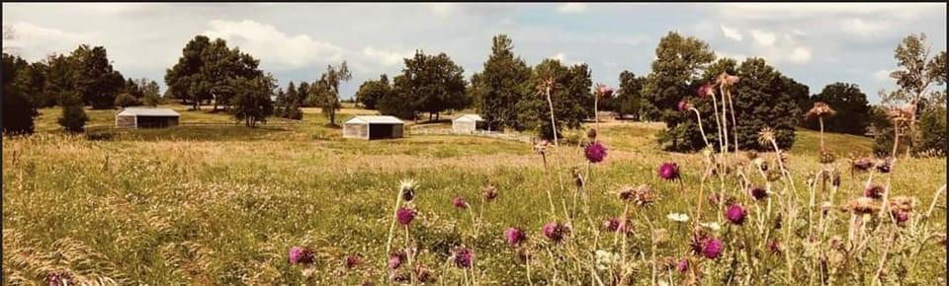We're Hiring!! Full Time Seasonal Landscape Labourer

Job Description:
A residential estate property in Dufferin County, twenty minutes from Orangeville in Mono. Our property is situated on 125 acres and includes both forests and meadows, as well as a young fruit orchard, vegetable gardens, and native tree re-planting.
We are looking to add to our skilled crew to assist the Property Manager and will work together to improve and maintain the property. Previous experience an asset.

General Duties
- operating and maintaining medium-sized farm equipment (tractors, skid steer, etc.)
- ‎chainsaw experience including tree felling an asset; pruning and tree health; hiking trail maintenance
‎- light carpentry, building/ mechanical repairs
- general gardening, landscaping and hardscaping
- operation of small landscape equipment (mowers, line trimmers, blowers)
-Planting trees, shrubs, perennials, and annuals
-Spring and Fall clean up
-Take direction and work alongside team leaders
-Follow on-site health and safety procedures

Job Requirements
You are interested in natural conservation and restorative agriculture and believe in healthy/ safe working conditions.
You are trustworthy and well-organized.
Must possess the physical and technical capabilities to perform the duties of the position
Team oriented and able to complete all tasks assigned
Hard working and self-motivated
Must be able to work outdoors in a variety of weather conditions
Have a valid driver's license and are permitted to work in Canada

This is a full-time, seasonal position with an opportunity to grow with us.
Salary $18-22 based on experience. 40 hrs/week Monday-Friday No weekends or holidays required.
Big Hat Farm Corp. is a smoke-free workplace in Mono, ON L9W 6M4

Forward resume and references to karen@bighat.farm

